**Accounting and Financial Analytics with zoho books**

**Assignment – 4**

**Task 1 – Stock Market Analysis**

**Objective :** Analyzing the performance of WALMART.INC over the past year

**INTRODUCTION**



In short, Walmart is a multinational retail corporation founded in 1962 by Sam Walton. It operates a wide range of retail formats, including hypermarkets, discount stores, and grocery stores, both domestically and internationally. Walmart is known for its commitment to providing low prices, extensive product selection, and customer satisfaction. It has a significant presence in e-commerce and is one of the largest employers globally. Despite its success, Walmart has faced criticism and controversies related to labors practices, impact on small businesses, and environmental concerns.

**Key businesses**

Walmart's key businesses encompass several areas within the retail industry:

1. **Retail Stores**: Operating a vast network of hypermarkets, discount stores, and grocery stores under various banners like Walmart Supercenter, Walmart Discount Store, Neighborhood Market, and Sam's Club.

2. **E-commerce**: Expanding its online presence through Walmart.com and acquisitions like Jet.com and Flipkart, allowing customers to shop online for a wide range of products.

3. **Supply Chain and Logistics**: Managing an efficient supply chain network, including distribution centers and transportation, to ensure product availability and timely delivery to stores and customers.

4. **Private Label Brands**: Developing and marketing private label brands across categories such as food, apparel, household goods, and electronics, offering customers quality products at competitive prices.

5. **Financial Services**: Providing financial services like Walmart MoneyCard (prepaid debit card), check cashing, money transfers, and bill payment services, enhancing convenience for customers.

6. **Membership Clubs**: Operating Sam's Club, a membership-based warehouse club offering bulk products, exclusive deals, and services to businesses and individual members.

7. **Healthcare Services**: Expanding into healthcare with initiatives like Walmart Health, offering affordable primary care, dental, and vision services in select locations.

8. **International Operations**: Managing retail operations in multiple countries, adapting to local markets and consumer preferences while maintaining Walmart's core values and business strategies.

**DATA ANALYSIS**

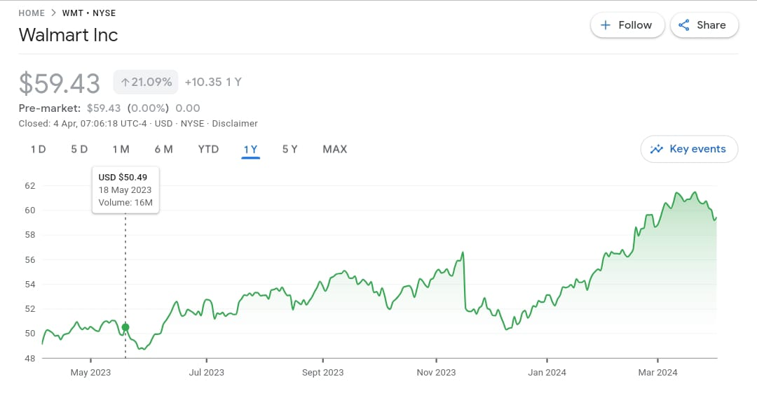

**Key metrics**

Certainly, Walmart, like many large corporations, tracks several key metrics to measure its performance and guide decision-making. Some key metrics for Walmart may include:

1. **Revenue**: Total income generated from sales of goods and services across all Walmart stores and online platforms.

2. **Comparable Store Sales Growth**: Percentage change in sales at stores open for more than a year, providing insight into organic growth and customer demand.

3. **E-commerce Sales Growth**: Growth rate of online sales through Walmart's website and other e-commerce channels, reflecting the success of its digital initiatives.

4. **Gross Margin**: Percentage of revenue retained after deducting the cost of goods sold, indicating efficiency in pricing and inventory management.

5. **Operating Margin**: Percentage of revenue remaining after deducting operating expenses, reflecting the efficiency of Walmart's operations.

6. **Inventory Turnover**: Number of times inventory is sold and replaced within a specific period, indicating how effectively Walmart manages its inventory levels.

7. **Return on Investment (ROI)**: Measurement of the return generated from investments in various areas such as new store openings, technology upgrades, and marketing campaigns.

8. **Customer Satisfaction Scores**: Feedback from customers through surveys, reviews, and ratings, reflecting overall satisfaction with Walmart's products and services.

9. **Employee Turnover Rate**: Percentage of employees leaving the company within a given period, indicating employee satisfaction and retention.

10. **Supply Chain Performance Metrics**: Metrics such as on-time delivery, fill rate, and inventory accuracy, ensuring efficient and reliable supply chain operations.

11. **Sustainability Metrics**: Progress towards environmental sustainability goals, such as reducing carbon emissions, increasing renewable energy usage, and minimizing waste.

12. **Net Promoter Score (NPS)**: Measurement of customer loyalty and likelihood to recommend Walmart to others, indicating brand perception and customer advocacy.

These key metrics provide Walmart with valuable insights into its financial performance, operational efficiency, customer satisfaction, and overall business health, guiding strategic decisions and continuous improvement efforts.

**Historical annual stock price data**

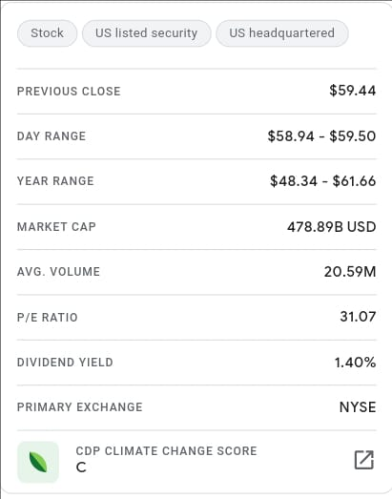

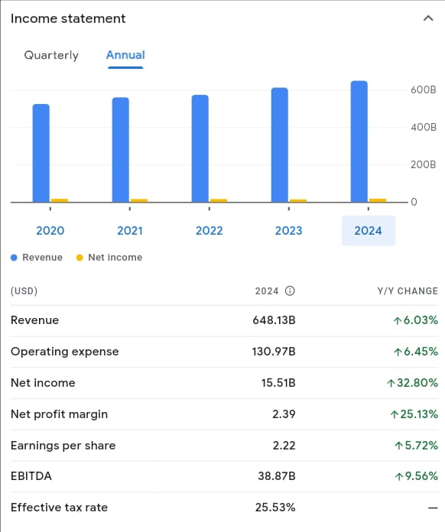

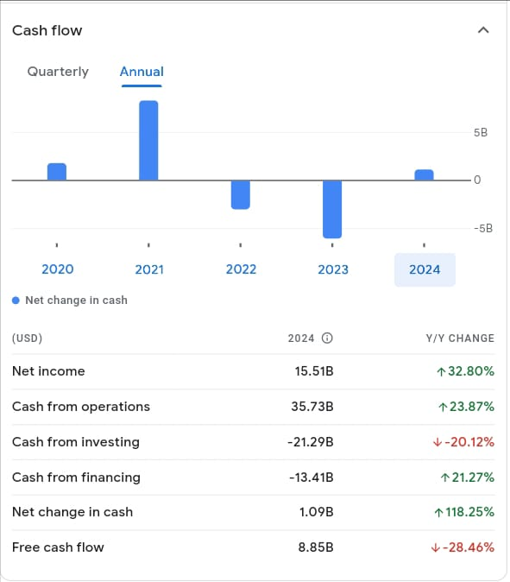

**Volatility**

As of my last update in January 2022, Walmart's stock volatility can be assessed using various metrics and factors:

1. **Historical Volatility**: Examining the historical price movements of Walmart's stock over different time periods to determine the degree of fluctuation.

2. **Implied Volatility**: Assessing the market's expectation of future volatility based on options pricing. High implied volatility indicates expectations of significant price movements, while low implied volatility suggests expectations of relatively stable prices.

3. **Beta**: Walmart's beta value compared to a benchmark index, such as the S&P 500, can indicate how volatile the stock is relative to the broader market. A beta greater than 1 suggests higher volatility, while a beta less than 1 indicates lower volatility.

4. **Standard Deviation**: Calculating the standard deviation of Walmart's stock returns over a specific period to quantify the level of volatility.

5. **Trading Volume**: Monitoring the trading volume of Walmart's stock, as higher trading volume can contribute to increased volatility due to heightened investor activity and liquidity.

6. **Event-Based Volatility**: Walmart's stock may experience increased volatility in response to corporate events (e.g., earnings announcements, acquisitions, strategic decisions), industry developments, economic indicators, or broader market trends.

7. **Financial Performance**: Changes in Walmart's financial results, such as revenue growth, earnings reports, and guidance updates, can impact investor sentiment and contribute to stock volatility.

8. **Macroeconomic Factors**: Economic conditions, consumer sentiment, interest rates, inflation, and geopolitical events can all influence Walmart's stock volatility.

While Walmart is generally considered a stable and well-established company, its stock can still experience fluctuations driven by various internal and external factors. Investors should carefully analyze these factors and consider their risk tolerance when evaluating Walmart's stock volatility.

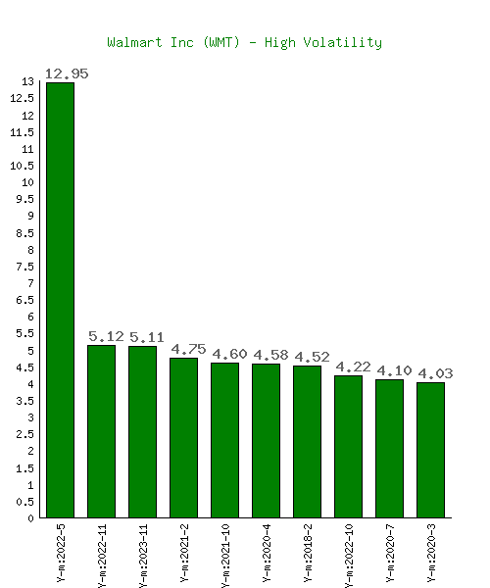

**Standard deviation**

As an AI language model, I don't have access to real-time data, including Walmart's current stock statistics. However, the standard deviation of Walmart's stock returns can be calculated using historical stock price data. Standard deviation measures the dispersion of a set of data points from its mean (average). In the context of stocks, it quantifies the degree of variability or volatility in stock returns.

To calculate the standard deviation of Walmart's stock returns, you would typically follow these steps:

1. Gather historical stock price data for Walmart over a specific period (e.g., daily, weekly, monthly).

2. Calculate the daily returns of Walmart's stock by taking the percentage change in stock price from one day to the next [(Price Today - Price Yesterday) / Price Yesterday].

3. Compute the average (mean) of the daily returns.

4. Calculate the squared difference between each daily return and the mean.

5. Find the average of the squared differences (variance).

6. Take the square root of the variance to get the standard deviation.

Here's a simplified formula to calculate standard deviation:

\[ \text{Standard Deviation} = \sqrt{\frac{\sum_{i=1}^{n}(x_i - \bar{x})^2}{n}} \]

Where:

- \( x_i \) = each individual daily return

- \( \bar{x} \) = average of all daily returns

- \( n \) = number of observations (number of daily returns)

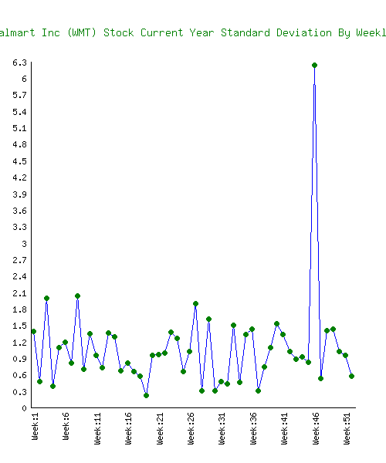

**Stock comparison and analysis**

 VS 

|  |  |  |  |  |  |  |  |  |  |  |  |  |  |  |  |  |  |  |  |
| --- | --- | --- | --- | --- | --- | --- | --- | --- | --- | --- | --- | --- | --- | --- | --- | --- | --- | --- | --- |
| Symbol | | | WMT | | | | AMZN | | | | |  | | | |  | |  | |
| Company | | | Walmart Inc | | | | Amazon.com Inc | | | | |  | | | |  | |  | |
| **Price Information** | | |  | | | |  | | | | |  | | | |  | |  | |
|  | | |
| Exchange | | | NYSE | | | | NASDAQ | | | | | |  | | |  | |  | |
| Open | | | 59.38 | | | | 179.90 | | | | | |  | | |  | |  | |
| High | | | 59.50 | | | | 182.87 | | | | | |  | | |  | |  | |
| Low | | | 58.94 | | | | 179.80 | | | | | |  | | |  | |  | |
| Last | | | 59.43 | | | | 182.41 | | | | | |  | | |  | |  | |
| Change | | | +0.27 | | | | +1.72 | | | | | |  | | |  | |  | |
| % Change | | | +0.46% | | | | +0.95% | | | | | |  | | |  | |  | |
| Volume | | | 14,615,101 | | | | 31,046,600 | | | | | |  | | |  | |  | |
| 20-Day Average Volume | | | 16,625,725 | | | | 34,414,863 | | | | | |  | | |  | |  | |
| Previous Close | | | 59.16 | | | | 180.69 | | | | | |  | | |  | |  | |
| Industry | | | Retail - Supermarket | | | | Internet Commerce | | | | | |  | | |  | |  | |
| Has Options | | | Yes | | | | Yes | | | | | |  | | |  | |  | |
| **Technicals** | | |  | | | |  | | | | | |  | | |  | |  | |
|  | | |
| 20-Day Moving Average | | | 60.60 | | | | 177.53 | | | | |  | | | |  | |  | |
| 20-Day Raw Stochastic | | | 19.82% | | | | 94.88% | | | | |  | | | |  | |  | |
| 20-Day Relative Strength | | | 52.15% | | | | 63.59% | | | | |  | | | |  | |  | |
| Weighted Alpha | | | +20.22 | | | | +76.89 | | | | |  | | | |  | |  | |
| Today's Opinion | | | 80% Buy | | | | 100% Buy | | | | |  | | | |  | |  | |
| Previous Opinion | | | 80% Buy | | | | 100% Buy | | | | |  | | | |  | |  | |
| Last Month's Opinion | | | 100% Buy | | | | 100% Buy | | | | |  | | | |  | |  | |
| **Performance** | | |  | | | |  | | | | |  | | | |  | |  | |
|  |
| **5-Days** |  | | | | | | | | | | | | | | | | | | |
| %Chg | -1.78% since 03/26/24 | | | | +2.31% since 03/26/24 | | | |  |  | | | |  | | | | | |
| Low | 58.88 on 04/02/24 | | | | 177.31 on 03/27/24 | | | |  |  | | | |  | | | | | |
| High | 61.05 on 03/27/24 | | | | 183.00 on 04/01/24 | | | |  |  | | | |  | | | | | |
| **1-Month** |  | | | | | | | | | | | | | | | | | | |
| %Chg | +1.14% since 03/01/24 | | | | +2.35% since 03/01/24 | | | |  |  | | | |  | | | | | |
| Low | 58.40 on 03/04/24 | | | | 171.47 on 03/11/24 | | | |  |  | | | |  | | | | | |
| High | 61.65 on 03/21/24 | | | | 183.00 on 04/01/24 | | | |  |  | | | |  | | | | | |
| **3-Month** |  | | | | | | | | | | | | | | | | | | |
| %Chg | +11.92% since 01/03/24 | | | | +22.86% since 01/03/24 | | | |  |  | | | |  | | | | | |
| Low | 51.87 on 01/05/24 | | | | 144.05 on 01/04/24 | | | |  |  | | | |  | | | | | |
| High | 61.65 on 03/21/24 | | | | 183.00 on 04/01/24 | | | |  |  | | | |  | | | | | |
| **6-Month** |  | | | | | | | | | | | | | | | | | | |
| %Chg | +12.07% since 10/03/23 | | | | +46.26% since 10/03/23 | | | |  |  | | | |  | | | | | |
| Low | 49.85 on 12/11/23 | | | | 118.35 on 10/26/23 | | | |  |  | | | |  | | | | | |
| High | 61.65 on 03/21/24 | | | | 183.00 on 04/01/24 | | | |  |  | | | |  | | | | | |
| **Key Statistics** |  | | | |  | | | |  |  | | | |  | | | | | |
| Market Capitalization, $K | | | | 478,889,792 | | | | 1,894,762,240 | | | | |  | | |  | |  | |
| Shares Outstanding, K | | | | 8,058,048 | | | | 10,387,381 | | | | |  | | |  | |  | |
| Annual Sales | | | | 648,125,000,000 | | | | 574,785,000,000 | | | | |  | | |  | |  | |
| Annual Net Income | | | | 15,511,000,000 | | | | 30,425,000,000 | | | | |  | | |  | |  | |
| Last Quarter Sales | | | | 173,388,000,000 | | | | 169,961,000,000 | | | | |  | | |  | |  | |
| Last Quarter Net Income | | | | 5,494,000,000 | | | | 10,624,000,000 | | | | |  | | |  | |  | |
| 60-Month Beta | | | | 0.49 | | | | 1.16 | | | | |  | | |  | |  | |
| **Per-Share Information** | | | |  | | | | | | | | | | | | | | | |
| Most Recent Earnings | | | | 0.60 on 02/20/24 | | | | 1.01 on 02/01/24 | | | | |  | | |  | |  | |
| Latest Earnings Date | | | | 05/16/24 | | | | 04/25/24 | | | | |  | | |  | |  | |
| Most Recent Dividend | | | | 0.207 on 03/14/24 | | | | N/A | | | | |  | | |  | |  | |
| Next Ex-Dividends Date | | | | 05/09/24 | | | | 12/27/22 | | | | |  | | |  | |  | |
| **Ratios** | | | |  | | | | | | | | | | | | | | | |
| Price/Earnings ttm | | | | 26.73 | | | | 64.53 | | | | |  | | |  | |  | |

T.RAVI KUMAR

DR LANKAPALLI BULLAYA COLLEGE

ANDHRA UNIVERSITY